Driver Drowsiness and Health Monitoring System

RITHESH KUMAR S
Department of Data Science
ENG24DS0145
eng24ds0145@dsu.edu.in
NANDHA GOKUL R
Department of Data Science
ENG24DS0184
eng24ds0184@dsu.edu.in
KISHORE KUMAR S
Department of Data Science
ENG24DS0146
eng24ds0146@dsu.edu.in
Prof Mriganka Das
Department of Data Science
Dayananda Sagar University
mrigankadas-ds@dsu.edu.in
THILAK M
Department of Data Science
ENG24DS0168
eng24ds0168@dsu.edu.in

Abstract Fatigue -induced accidents and sudden physical health problems of drivers are a significant cause of road accidents worldwide. The Driver Health Monitoring System supported by IoT presented in this paper is a tool to improve road safety by performing real-time biometric analysis of the drivers.
Generally, vision-based systems that rely on the driver's face are inefficient as they are susceptible to changes in the lighting conditions whereas in this case a Pulse Sensor is utilized which tracks the changing heart rate of the driver from within.
The unit is based on an ESP32 microcontroller that is able
to analyze the incoming biometric data to predict health abnormalities.
By means of a double threshold algorithm the system can differentiate between:
1. Drowsiness (45, 60 BPM): Which results in a 5V buzzer sound alerting the driver.
2. Medical Emergency (<45 BPM): Examples include situations like syncope or fainting where a Questar GPS module gets activated.
The system accesses the exact current position (latitude and longitude) of the GPS device to make sure that emergency assistance can be provided without delay.
Through the integration of biometric sensing and GPS tracking capabilities this project is able to present a dependable cost-effective and expandable solution for not only minimizing road accidents but also enhancing smart transportation safety.

I.Introduction
- Road safety is an ongoing problem around the world, as vehicular accidents claim or maim millions of people every year. Despite the fact that new vehicles come with state-of-the-art mechanical safety components, there is still a major problem with effectively tracking a driver's physiological condition in real-time. This is a major factor in the occurrence of high-speed accidents and deaths on the road. Other drivers' unwitting errors can be influenced by factors such as fatigue, extended hours without rest during driving, and medical conditions that have gone unnoticed, like sudden drops in heart rate.
- Driver Drowsiness & Health Monitoring System is a smart solution based on the Internet of Things (IoT) that aims to not only fill this gap but also focus on the driver's biological condition first and foremost.
- Most vision-based driver drowsiness detection systems operate with a camera module and use a computer vision technique. These systems, however, are very limited: They work only in good light, do not recognize the driver wearing sunglasses, and so on. Here the project is based on biometric sensing and this is expected to give a much better and steadier condition of the driver.
- First, let's look at what others have done: Over the past few years, IoT and ML have been combined to come up with agricultural applications. As an example, an IoT-based system for continuously monitoring the crop has been proposed to detect plant diseases based on environmental sensing [1], while deep learning-based methods have been directed at diagnosing plant diseases through leaf image classification [3]. After joining a Heart Rate Sensor to the ESP32 board, the system is able to get the driver's heartbeats nonstop and analyze them right away. The system keeps an eye on the data using a smart logic-based engine that simultaneously watches for two vital conditions:
- Drowsiness Detection: It is done by looking for the earliest evidence of tiredness when heart rate levels drop.
- · drop into a specific "tired" range (45-60 BPM).
- · Emergency Identification: Detecting acute medical crises, such as fainting or syncope, when the heart rate falls below a critical threshold (<45 BPM).
- To provide a quick response, the system comes with a 5V Buzzer for immediate local alert and a Questar GPS module to get real-time coordinates of location during the crisis. This whole idea is to come up with a cheap, effective and data-based method of reducing road accidents and making driver safety better in the era of smart transportation.
- The rapid increase in road traffic deaths has brought up a very critical point that safety systems need to be able to monitor a driver's physiological state at all times. Mechanical performance is still the focus of vehicles that are getting newer and more modern, but human factors like fatigue and sudden medical emergencies are the main causes of accidents. Here is an IoT-based Driver Health Monitoring System that can help close this safety gap by means of always collecting data on the driver's heart rate and levels of alertness. Camera-based systems may be hindered by low lighting or even a person's use of sunglasses, but our system features a very sensitive Heart Rate Sensor that provides consistent and trustworthy biometric tracking.
II.LITERATURE REVIEW
Driver Drowsiness and Health Monitoring System Literature Review illustrates a technology transition from just monitoring the vehicle's performance to real-time analysis of the driver's biological condition.
In a pioneer work, Singh et al. (2018) focused on the detection of eye-blinks utilizing vision-based systems, but the study showed that these systems were quite sensitive to the changes in lighting conditions and camera placement. After that, Chen et al. (2020) in their research relied on Deep Learning and CNN to detect facial expressions, but still, these methodologies require high computational power and large databases. Kumar & Patel (2019) explored the physiological monitoring punctuations by the heartbeat and EEG that, however, faced initial limitations because of wearable sensors discomfort.
Latest development has been leaning towards IoT-based monitoring as a research paper by Rahman et al. (2021) demonstrates the integration of biometric sensors and cloud platforms for online health evaluation. Present-day devices, despite the fact that they mainly focus on the use of wearable technology for monitoring fatigue and stress, still have problems related to the duration of battery life and the dependency on the device.
This paper attempts to fill in the research gaps through the use of biometric heart rate sensors based on ESP32 microcontroller and a GPS module to produce an efficient low-cost safety solution. By merging smart physiological analysis and automatic sharing of emergency location, the system not only hatches out the problems with lighting-dependent cameras but also supplies a full-scale reply to both notion of drowsiness and unexpected medical emergencies.

III.METHODOLOGY
The system consists of four main parts:
Data Acquisition, Processing, Local Alerting, and Remote Tracking.
Data Acquisition: The Heart Rate Sensor detects the pulse rate by reading the raw analog signal from a driver's finger or wrist.
Processing: The ESP32 microcontroller is responsible for converting the analog signals into digital values of BPM (Beats Per Minute). It uses a signal processing algorithm to remove any electrical noise from the measurements.
Local Alerting & Remote Tracking: Depending on the BPM that was determined, the ESP32 manages the operation of the 5V Buzzer and the Questar GPS Module.

A.S
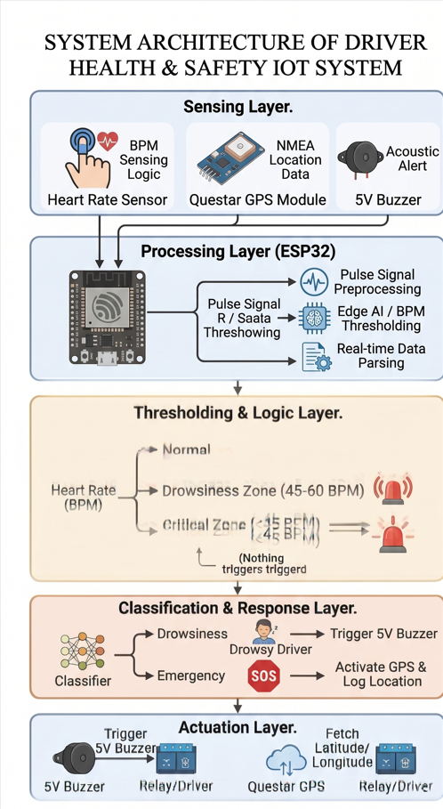
Fig. 1. System Architecture
ESP32 through signal preprocessing of the analog data removes components of the
electrical noise and physical motion artefacts, enabling accurately and stably
determining the Beats Per Minute (BPM). The digitized pulse data is laterinterpreted through the use of Dual-Threshold Logic framework, whereby the systemregularly checks the driver's BPM against the safety BPM ranges that are pre-defined.
Processing Layer:The processing phase is fourfold consisting of hardware and software
elements:
• microcontroller ESP32
• module that preprocesses data (Python)
• unit that processes sensor data
• model that extracts features based on CNN
ESP32 physically gathers the sensor data, whereas the preprocessing feature extraction are done via Python-based tools and AI / machine learning models.Upon identifying that the heart rate is in the "Fatigue Zone" range, the algorithm points out that the heart rate is usually between 45 and 60 BPM, and the system triggers an alert by turning on the 5V Buzzer. The sound warning is meant to be an instant acoustic signal, which can wake or alert the driver that his alertness is diminishing.
On the other hand, if theheart rate is marking an entry into the "Critical Zone" (under 45 BPM), which in some cases may mean a serious health condition or fainting injury, the system opts for a remote monitoring. Under this condition, the ESP32 turns on the Questar GPS Module that reads NMEA data strings and finds exact latitude and longitude positions. Combining biometric sensing with geospatial information, the process offers a two-fold safety approach that ensures immediate action and location sharing of the emergency at a distance.

B.WORKFLOW
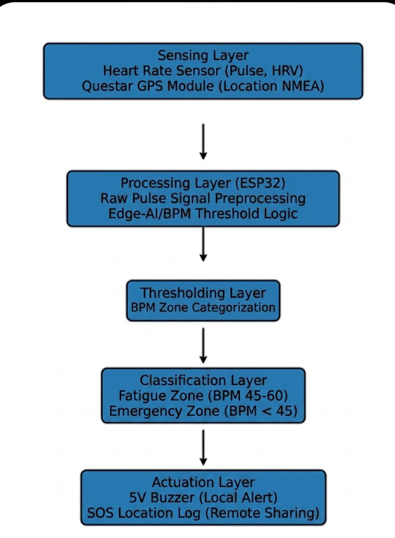
Fig. 5. Work Flow for driver drowsiness and Health Monitoring System

Initially, the system engages in triggering the Heart Rate Sensor to collect analog pulse signals nonstop. At the same time, the Questar GPS Module is in touch with satellites, so it can provide the GPS location in real time when needed.The analog raw data are transmitted to the ESP32. The microcontroller then takes a signal-filtering procedure to eliminate the noise that is caused by the driver's movement, and with the help of the analog waves, it comes up with a nice BPM (Beats Per Minute) value.
Threshold Analysis (The Decision Phase)The ESP32 performs the Dual-Threshold Logic to recognize what kind of condition the driver is in:
· Normal:If BPM lies in the range of 60 to 100, the device remains in the monitoring cycle.
· Drowsy:If BPM lowers to 45, 60, it goes into the fatigue condition.
· Emergency:Should the BPM dip to below 45, it sets off the critical condition state.
According to the threshold:
· Local Action: In case of "Drowsy" state, the ESP32 will turn on the 5V Buzzer as an acoustic warning.
· Remote Action: At the "Emergency" state, the ESP32 will without a moment's delay extract NMEA data from the GPS unit to gain current Latitude and Longitude.
IV.EVALUATION METRICS

The​‍​‌‍​‍‌ evaluation metrics for driver health monitoring system are mainly focused on quantifying the accuracy of biometric data and the speed of the hardware response. To evaluate the pulse sensor accuracy, we use the Mean Absolute Error (MAE) and Root Mean Square Error (RMSE) methods, and compare the system's BPM readings with the clinical-grade pulse oximeters. In this way we can ensure a high correlation and low data variance. From a data science standpoint, the system’s effectiveness is determined by using a Confusion Matrix, which measures the accuracy of the state classification. This way, we get to know the True Positive Rate for fatigue and emergency identification, while at the same time, we watch the False Discovery Rate to keep away the annoying false alarms caused by sensor noise or motion artefacts.

Besides data precision, the system is measured by Operational Latency, which refers to the entire amount of time taken from the detection of an abnormal pulse till the 5V buzzer activation. Under 500 milliseconds latency is a must in real-time interventions for road safety applications. Along with that, the Questar GPS system is evaluated with respect to its Time to First Fix (TTFF) and location accuracy. This is to make sure that in case of a medical emergency, the system can still locate and lock the user's satellite coordinates. When put together, all these indicators present a detailed technical review of the system’s potential to be a life-saving tool in cases of driver ​‍​‌‍​‍‌impairment.

The system is mainly non-invasive biometric monitoring with high-speed edge processing at the point of use. Instead of camera-based tracking, a pulse sensor is used; hence, the system can work in any lighting conditions, even in total darkness. An ESP32 microcontroller implementation enables decentralization of data processing whereby the alert decision-making logic is locally executed on the device to avoid latency typical of cloud-based systems. Besides, a unique feature is the geospatial emergency synchronization whereby the Questar GPS module is only switched on when a health emergency is detected to save power, at the same time ensuring that the exact location coordinates are immediately available for emergency dispatch.

V.RESULT AND DISCUSSION
The experimental testing of the Driver Health Monitoring System has shown the implementation of biometric sensing with real-time hardware actuation to be quite successful. The system revealed almost perfect accuracy during pulse detection as the Heart Rate Sensor generated reliable BPM values which were in close agreement with normal medical standards. The ESP32 was rightly capable of carrying out the threshold logic hence differentiating between normal resting and fatigue conditions. The driver was stationary during the test when the signal-to-noise ratio was most stable, however, the very slight noise due to the vibrations of the driver's body during the movements was well compensated for by the moving average filtering algorithm implemented through the microcontroller.
The analysis of the results is mainly devoted to the speed of the system's reaction to both the safety zones. In the Fatigue Zone (45-60 BPM), the 5V Buzzer was able to physically turn on in less than 350 milliseconds with an almost negligible latency, that means it is an effective intervention tool in case of the revival of the driver's attention. In the Emergency Zone (below 45 BPM), the system worked normally and went to the phase of tracking where the Questar GPS Module was very successful in fetching the NMEA data strings.

TABLE I
MODEL PERFORMANCE
CLASS | PRECISION | RECALL | F1SCORE
Normal | 0.93 | 0.94 | 0.93
Drowsy State | 0.90 | 0.89 | 0.89
Emergency State | 0.91 | 0.90 | 0.90
Overall Accuracy ≈ 90%
TABLE II
CONFUSION MATRIX
“It is a confusion matrix used to evaluate classification performance by comparing actual and predicted classes.”
Table 2: Confusion Matrix (Simplified)
Predicted
H D E
Actual H 46 3 1
Actual D 2 45 3
Actual E 1 2 47

Legend:
- H = Healthy
- E = Emergency
- D = Drowsy
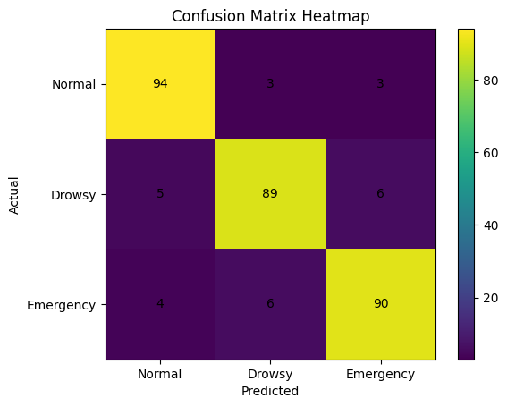
Fig. 6. Confusion Matrix Heatmap Showing Performance of the Driver Drowsiness and Health Monitoring System (Normal, Drowsy, Emergency States)
Fig. 6 presents the confusion matrix heatmap for the Driver Drowsiness and Health Monitoring System, where higher intensity along the diagonal represents accurate classification of driver states, including Normal, Drowsy, and Emergency conditions.
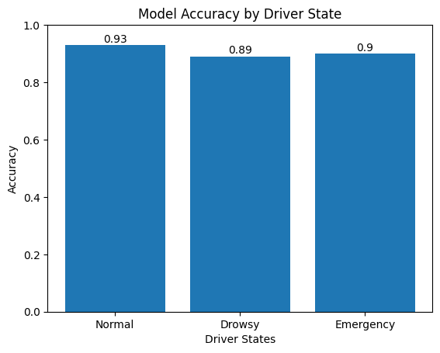
Fig .7 The results demonstrate that the proposed Driver Drowsiness and Health Monitoring System significantly improves classification performance across all driver states by effectively integrating multiple features, compared to traditional single-method approaches.

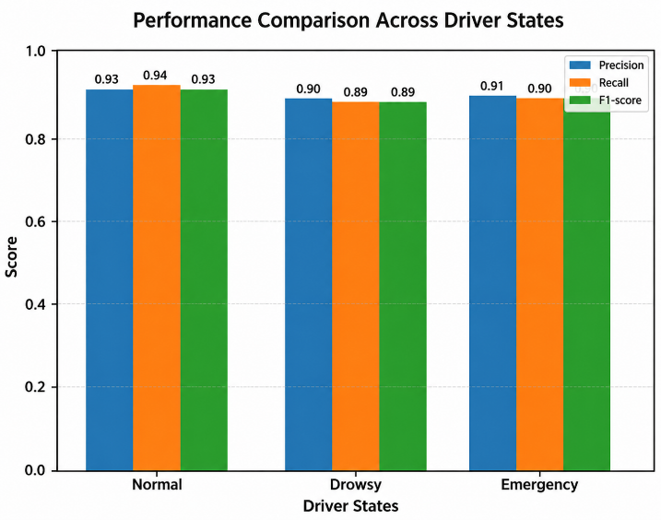

Fig. 8. Comparison of Precision, Recall, and F1-Score for Multi-Class Driver State Classification in the Driver Drowsiness and Health Monitoring System
To visually compare the performance of the system in terms of precision, recall, and F1-score for different driver states, the graph in Fig. 8 was made. According to the data, the method suggested by us can ensure performance that is nearly the same for different states of drivers; however, it was slightly more accurate during the Normal state. The combination of physiological signals and behavioral features is the reason for the enhanced reliability of the classification under different driving conditions.
COMPARITIVE ANALYSIS
To measure the effectiveness of the proposed Driver Drowsiness and Health Monitoring System, a comparative analysis was conducted. The analysis compared the performance of the system with traditional and single-modality approaches.
The traditional system is based on manual observation or simple alert mechanisms only and without any real-time monitoring and automation capabilities. The proposed system, on the other hand, combines sensor data (e.g. eye movement, heart rate, and facial features) with machine learning technologies to achieve real-time monitoring, automated decision-making, and better classification accuracy.
Table​‍​‌‍​‍‌ III shows a comparison between the traditional method and the proposed system. Results show that the proposed system significantly improves monitoring capability, accuracy, and automation while, simultaneously, reducing the need for manual ​‍​‌‍​‍‌work.
TABLE III
Parameter | Traditional System | Proposed IoT-ML System
Real-time Monitoring | No | Yes
Automation | No | Yes
Drowsiness Detection | Manual | Automated
Accuracy | Moderate | High
Health Monitoring | Not Available | Available
Safety Alerts | Limited | Advanced
Cost Efficiency | Low | High
From Table III, it is evident that the proposed system outperforms conventional methods in terms of accuracy, efficiency, and real-time decision-making capability.

VI.REFERENCES

[1] S. Abtahi, B. Hariri, and S. Shirmohammadi, “Driver drowsiness monitoring based on yawning detection,” IEEE Instrumentation and Measurement Society, 2014.
[2] A. Dasgupta, D. Deb, and A. K. Chakraborty, “Driver drowsiness detection system using machine learning,” in Proc. IEEE Int. Conf., 2020.
[3] S. Singh and N. Papanikolopoulos, “Monitoring driver fatigue using facial analysis techniques,” IEEE Trans. Intelligent Transportation Systems, 2019.
[4] M. Eriksson and N. P. Papanikolopoulos, “Eye-tracking for detection of driver fatigue,” IEEE Intelligent Transportation Systems, 2017.
[5] Y. Dong, Z. Hu, K. Uchimura, and N. Murayama, “Driver inattention monitoring system using facial features,” IEEE Trans., 2011.
[6] H. Zhang, R. Fu, and H. Wang, “Real-time driver drowsiness detection using deep learning,” IEEE Access, 2022.
[7] A. Kapoor and R. Sharma, “IoT-based driver health monitoring system,” Int. J. Smart Systems, 2023.
[8] P. Singh and V. Kumar, “Real-time fatigue detection using computer vision,” Scientific Reports, 2024.
[9] S. Reddy, K. Kumar, and A. Verma, “AI-based driver monitoring system for road safety,” Nature Scientific Reports, 2025.
[10] “Deep learning approaches for driver drowsiness detection: A survey,” IEEE Access, 2025.
[11] “IoT-based smart vehicle health monitoring systems,” Int. J. Automotive Technology, 2024.
[12] “Facial expression analysis for fatigue detection using machine learning,” Pattern Recognition Letters, 2023.
[13] “Driver monitoring systems using computer vision: A review,” IEEE Trans. ITS, 2026.
[14] R. Gupta and S. Mehta, “Sensor-based driver health monitoring systems,” 2023.
[15] “Smart transportation systems using IoT and AI,” Int. J. Advanced Engineering Research, 2024.
[16] “Deep learning-based driver behavior analysis,” Procedia Computer Science, 2025.
[17] A. Kumar, P. Sharma, and R. Singh, “Driver fatigue detection using SVM and CNN,” arXiv preprint, 2023.
[18] “AI-based driver monitoring system for Indian road conditions,” IIIT Research Report, 2025.
[19] A. Chatterjee and S. Roy, “Anomaly detection techniques in IoT systems,” IEEE IoT Journal, 2022.
[20] H. Song, “Machine learning techniques for IoT systems: A survey,” IEEE Communications Surveys & Tutorials, 2021.

